Hyperbola

Definition
# Source: AI Source: Provided by: [Data Path: Persons Table -> ID Column: 1, Name_En Column: Motasem Essam] -> From: [ChatGPT] on [7/25/2026]
A hyperbola is a conic section consisting of two separate, open curves called branches.
It is the set of all points in a plane for which the absolute difference between the distances to two fixed points is constant.
The two fixed points are called the foci.
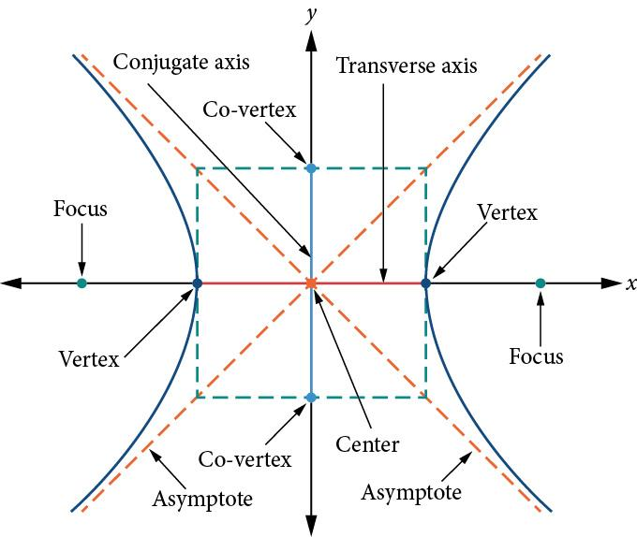
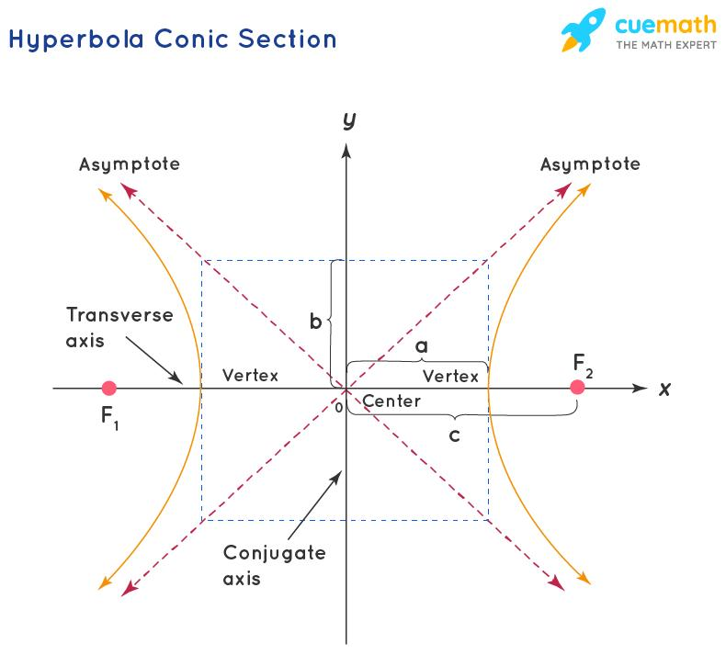
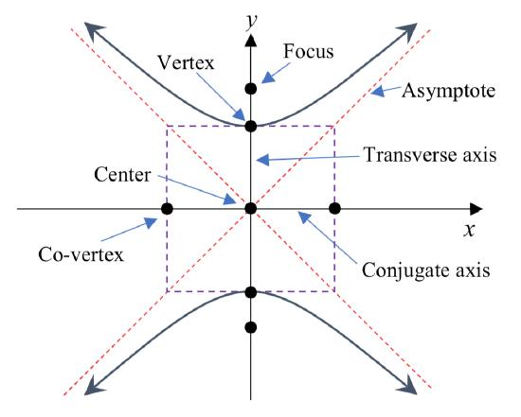
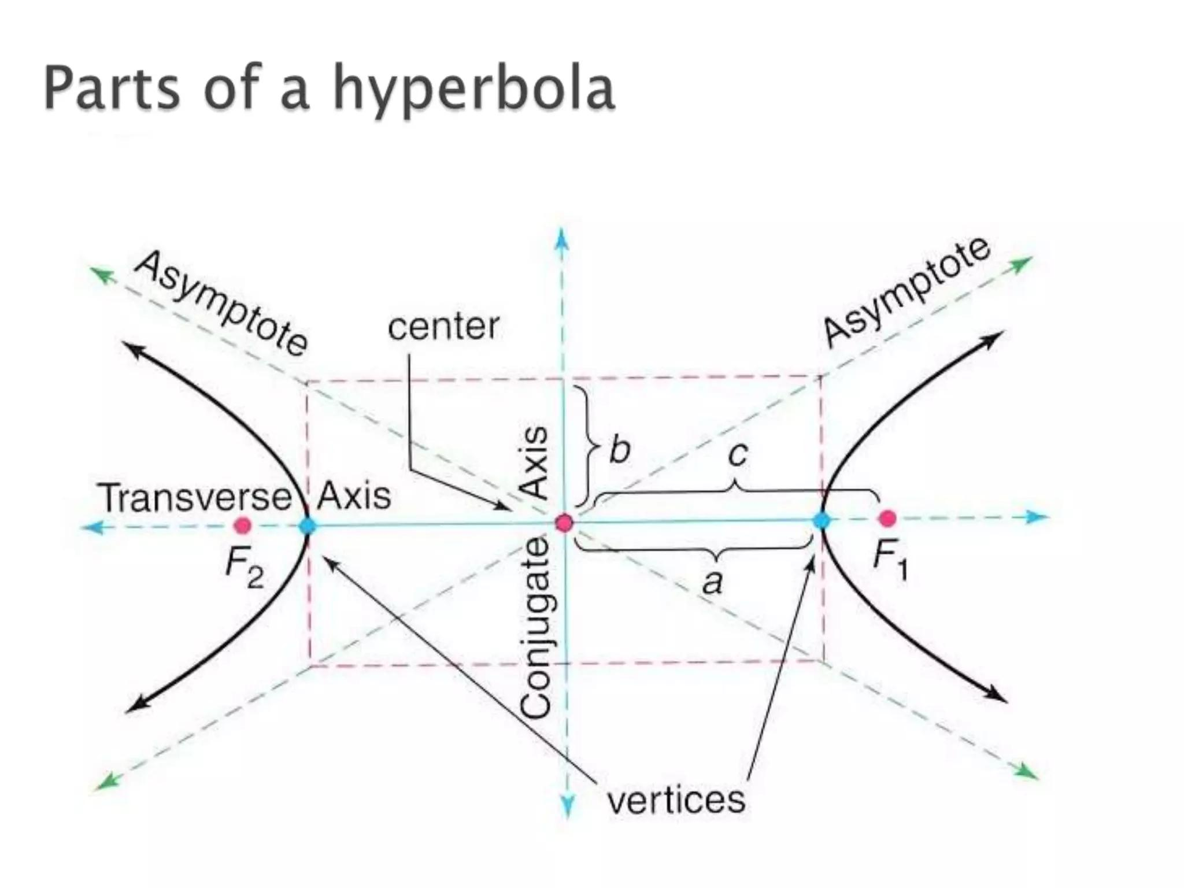
For any point $P$on a hyperbola with foci $F_{1}$and $F_{2}$:
$$\boxed{∣PF_{1}-PF_{2}∣=2a}$$
where $a$is the semi-transverse axis.

Fundamental Elements
# Source: AI Source: Provided by: [Data Path: Persons Table -> ID Column: 1, Name_En Column: Motasem Essam] -> From: [ChatGPT] on [7/25/2026]
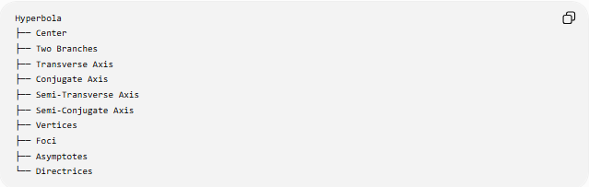
Hyperbola
├── Center
├── Two Branches
├── Transverse Axis
├── Conjugate Axis
├── Semi-Transverse Axis
├── Semi-Conjugate Axis
├── Vertices
├── Foci
├── Asymptotes
└── Directrices
1. Center
The center is the point about which the two branches of the hyperbola are symmetric.
It is commonly represented by:
$$\left(h , k\right)$$
2. Branches
A hyperbola has two separate branches.
The branches open in opposite directions.
3. Transverse Axis
The transverse axis passes through the center and the two vertices.
Its length is:
$$\boxed{2a}$$
4. Conjugate Axis
The conjugate axis is perpendicular to the transverse axis.
Its length is:
$$\boxed{2b}$$
5. Vertices
The vertices are the points where the branches intersect the transverse axis.
For a horizontal hyperbola:
$$\left(h , -ak\right), \left(h , +ak\right)$$
6. Foci
The foci are two fixed points associated with the hyperbola.
For a horizontal hyperbola:
$$\left(h , -ck\right), \left(h , +ck\right)$$
where:
$$\boxed{c^{2}=a^{2}+b^{2}}$$
Thus:
$$\boxed{c>a}$$

Standard Equations

Horizontal Hyperbola
# Source: AI Source: Provided by: [Data Path: Persons Table -> ID Column: 1, Name_En Column: Motasem Essam] -> From: [ChatGPT] on [7/25/2026]
When the transverse axis is horizontal:
$$\boxed{\frac{{\left(x-h\right)}^{2}}{a^{2}}-\frac{{\left(y-k\right)}^{2}}{b^{2}}=1}$$
The branches open left and right.
Vertices
$$\boxed{\left(h , -ak\right), \left(h , +ak\right)}$$
Foci
$$\boxed{\left(h , -ck\right), \left(h , +ck\right)}$$
where:
$$\boxed{c^{2}=a^{2}+b^{2}}$$

Vertical Hyperbola
# Source: AI Source: Provided by: [Data Path: Persons Table -> ID Column: 1, Name_En Column: Motasem Essam] -> From: [ChatGPT] on [7/25/2026]
When the transverse axis is vertical:
$$\boxed{\frac{{\left(y-k\right)}^{2}}{a^{2}}-\frac{{\left(x-h\right)}^{2}}{b^{2}}=1}$$
The branches open up and down.
Vertices
$$\boxed{\left(h , k-a\right), \left(h , k+a\right)}$$
Foci
$$\boxed{\left(h , k-c\right), \left(h , k+c\right)}$$
where:
$$\boxed{c^{2}=a^{2}+b^{2}}$$
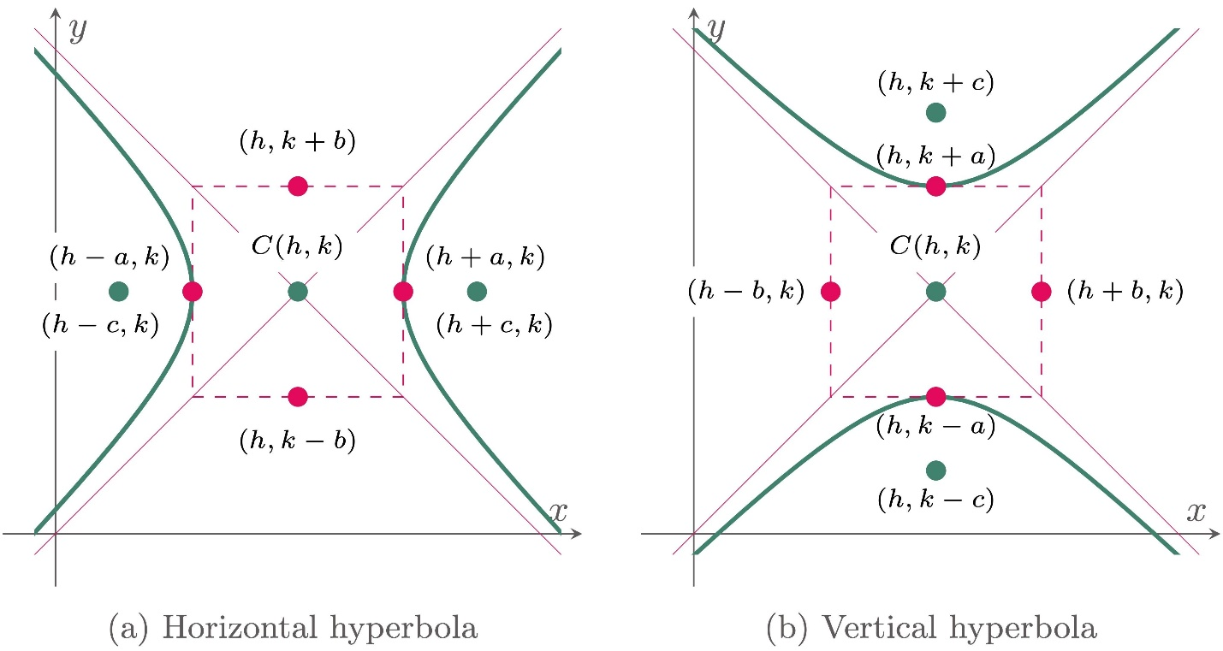
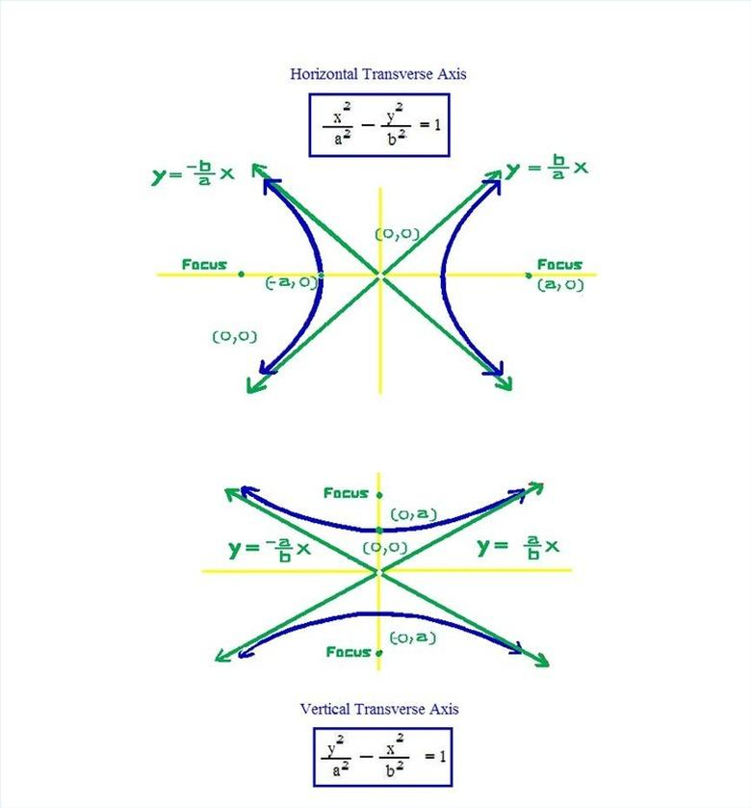
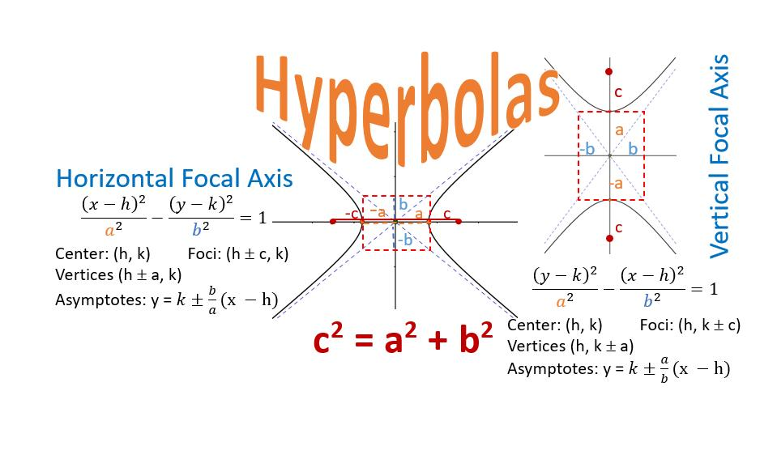

Eccentricity
# Source: AI Source: Provided by: [Data Path: Persons Table -> ID Column: 1, Name_En Column: Motasem Essam] -> From: [ChatGPT] on [7/25/2026]
The eccentricity of a hyperbola measures its shape.
$$\boxed{e=\frac{c}{a}}$$
Because:
$$c^{2}=a^{2}+b^{2}$$
we have:
$$c>a$$
Therefore:
$$\boxed{e>1}$$
An eccentricity greater than $1$is one of the defining characteristics of a hyperbola.

Focus-Directrix Definition
# Source: AI Source: Provided by: [Data Path: Persons Table -> ID Column: 1, Name_En Column: Motasem Essam] -> From: [ChatGPT] on [7/25/2026]
A hyperbola can also be defined using a focus and a directrix.
For any point $P$on the hyperbola:
$$\boxed{\frac{\text{distance from }P\text{ to focus}}{\text{distance from }P\text{ to directrix}}=e}$$
For a hyperbola:
$$\boxed{e>1}$$
This gives the unified focus-directrix definition of conic sections.

Asymptotes
# Source: AI Source: Provided by: [Data Path: Persons Table -> ID Column: 1, Name_En Column: Motasem Essam] -> From: [ChatGPT] on [7/25/2026]
An asymptote is a line that the branches of the hyperbola approach as they extend toward infinity.
For the horizontal hyperbola
$$\frac{{\left(x-h\right)}^{2}}{a^{2}}-\frac{{\left(y-k\right)}^{2}}{b^{2}}=1$$
the asymptotes are:
$$\boxed{y-k=±\frac{b}{a}\left(x-h\right)}$$
For the vertical hyperbola:
$$\boxed{y-k=±\frac{a}{b}\left(x-h\right)}$$
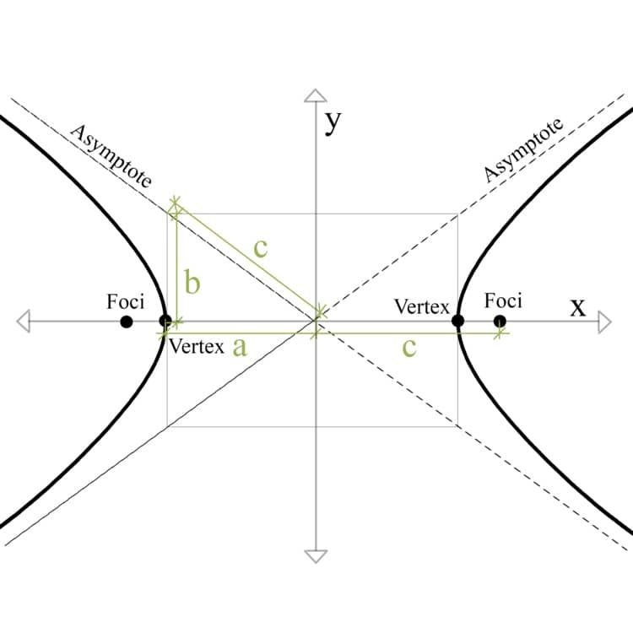
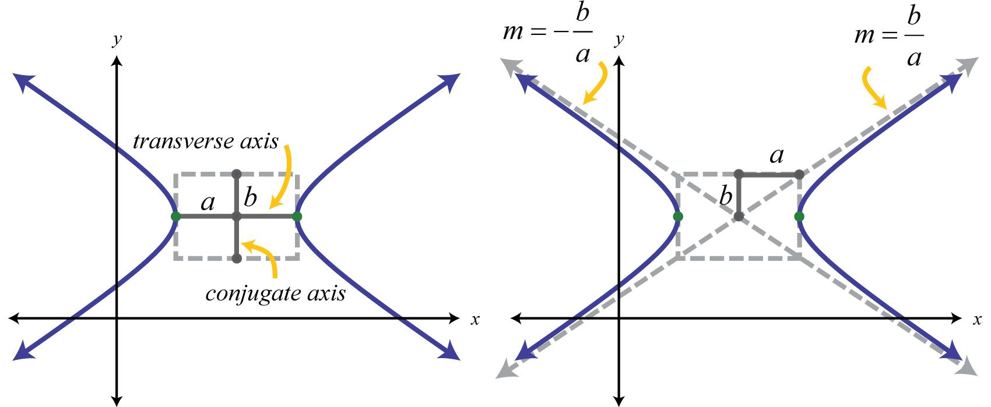
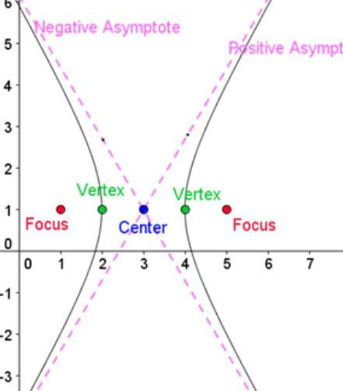
The asymptotes intersect at the center of the hyperbola.

Fundamental Relationship
# Source: AI Source: Provided by: [Data Path: Persons Table -> ID Column: 1, Name_En Column: Motasem Essam] -> From: [ChatGPT] on [7/25/2026]
For a hyperbola:
$$\boxed{c^{2}=a^{2}+b^{2}}$$
This differs from the corresponding ellipse relationship:
$$\text{Ellipse: }c^{2}=a^{2}-b^{2} \\ \text{Hyperbola: }c^{2}=a^{2}+b^{2}$$

Distance Property
# Source: AI Source: Provided by: [Data Path: Persons Table -> ID Column: 1, Name_En Column: Motasem Essam] -> From: [ChatGPT] on [7/25/2026]
For any point $P$on a hyperbola, the absolute difference between its distances to the two foci is constant:
$$\boxed{∣PF_{1}-PF_{2}∣=2a}$$
This is the fundamental geometric definition of a hyperbola.
Unlike an ellipse, which uses a sum:
$$PF_{1}+PF_{2}=2a$$
a hyperbola uses a difference:
$$∣PF_{1}-PF_{2}∣=2a$$

Types of Hyperbolas
# Source: AI Source: Provided by: [Data Path: Persons Table -> ID Column: 1, Name_En Column: Motasem Essam] -> From: [ChatGPT] on [7/25/2026]
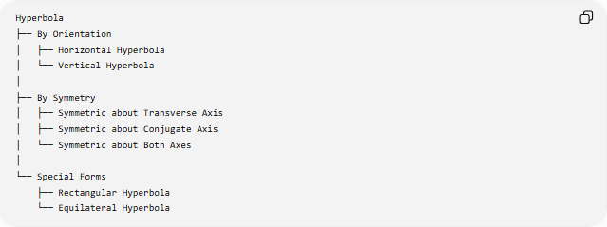
Hyperbola
├── By Orientation
│ ├── Horizontal Hyperbola
│ └── Vertical Hyperbola
│
├── By Symmetry
│ ├── Symmetric about Transverse Axis
│ ├── Symmetric about Conjugate Axis
│ └── Symmetric about Both Axes
│
└── Special Forms
├── Rectangular Hyperbola
└── Equilateral Hyperbola

Rectangular Hyperbola
# Source: AI Source: Provided by: [Data Path: Persons Table -> ID Column: 1, Name_En Column: Motasem Essam] -> From: [ChatGPT] on [7/25/2026]
A rectangular hyperbola, also called an equilateral hyperbola, is a hyperbola whose asymptotes are perpendicular.
For the standard form:
$$\boxed{x^{2}-y^{2}=a^{2}}$$
the asymptotes are:
$$y=x$$
and
$$y=-x$$
which meet at a right angle.

Example
# Source: AI Source: Provided by: [Data Path: Persons Table -> ID Column: 1, Name_En Column: Motasem Essam] -> From: [ChatGPT] on [7/25/2026]
Consider:
$$\frac{x^{2}}{25}-\frac{y^{2}}{16}=1$$
Compare with:
$$\frac{x^{2}}{a^{2}}-\frac{y^{2}}{b^{2}}=1$$
Therefore:
$$a^{2}=25, b^{2}=16$$
so:
$$a=5, b=4$$
Vertices
$$\boxed{\left(- , 50\right), \left(5 , 0\right)}$$
Foci
Using:
$$c^{2}=a^{2}+b^{2} \\ c^{2}=25+16=41 \\ c=\sqrt{41}$$
Therefore:
$$\boxed{\left(- , \sqrt{41}0\right), \left(\sqrt{41} , 0\right)}$$
Eccentricity
$$e=\frac{c}{a} \\ \boxed{e=\frac{\sqrt{41}}{5}≈1.281}$$
Asymptotes
$$y=±\frac{4}{5}x$$

Main Properties
# Source: AI Source: Provided by: [Data Path: Persons Table -> ID Column: 1, Name_En Column: Motasem Essam] -> From: [ChatGPT] on [7/25/2026]
- A hyperbola is a conic section.
- It has two separate branches.
- It has two foci.
- The difference between the distances to the two foci is constant.
- The constant difference is $2a$.
- It has two vertices.
- It has a center.
- Its two branches are symmetric about the transverse axis.
- It also has symmetry about the conjugate axis.
- It has two asymptotes.
- The asymptotes intersect at the center.
- The eccentricity satisfies:
$$\boxed{e>1}$$
- The focal relationship is:
$$\boxed{c^{2}=a^{2}+b^{2}}$$

Symmetry
# Source: AI Source: Provided by: [Data Path: Persons Table -> ID Column: 1, Name_En Column: Motasem Essam] -> From: [ChatGPT] on [7/25/2026]
A standard hyperbola has:
- 2 lines of reflection symmetry
- rotational symmetry of order 2
- central symmetry about its center.
For a horizontal hyperbola, the axes of symmetry are:
$$y=k$$
and
$$x=h$$

Hyperbola vs. Ellipse
# Source: AI Source: Provided by: [Data Path: Persons Table -> ID Column: 1, Name_En Column: Motasem Essam] -> From: [ChatGPT] on [7/25/2026]
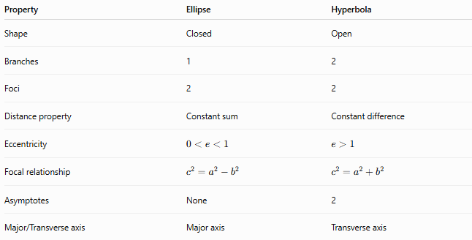
Property | Ellipse | Hyperbola
Shape | Closed | Open
Branches | 1 | 2
Foci | 2 | 2
Distance property | Constant sum | Constant difference
Eccentricity | $$0<e<1$$ | $$e>1$$
Focal relationship | $$c^{2}=a^{2}-b^{2}$$ | $$c^{2}=a^{2}+b^{2}$$
Asymptotes | None | 2
Major/Transverse axis | Major axis | Transverse axis
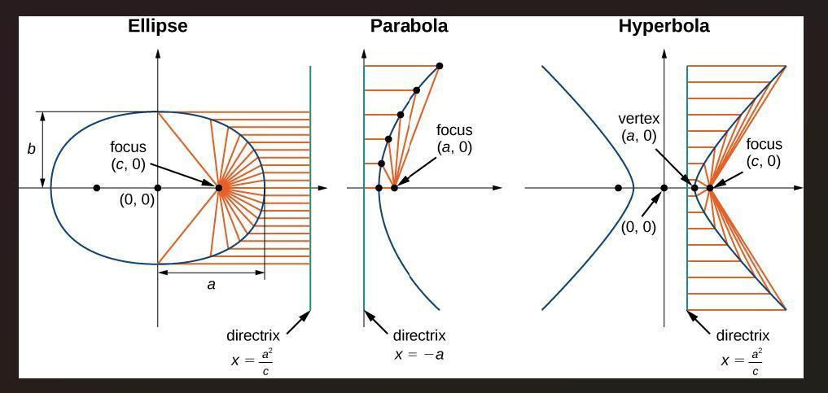
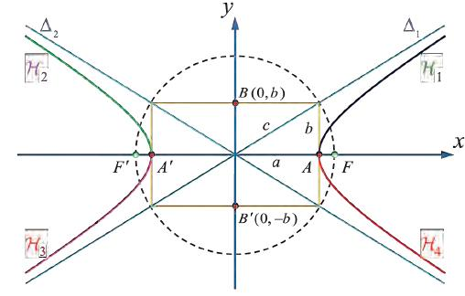
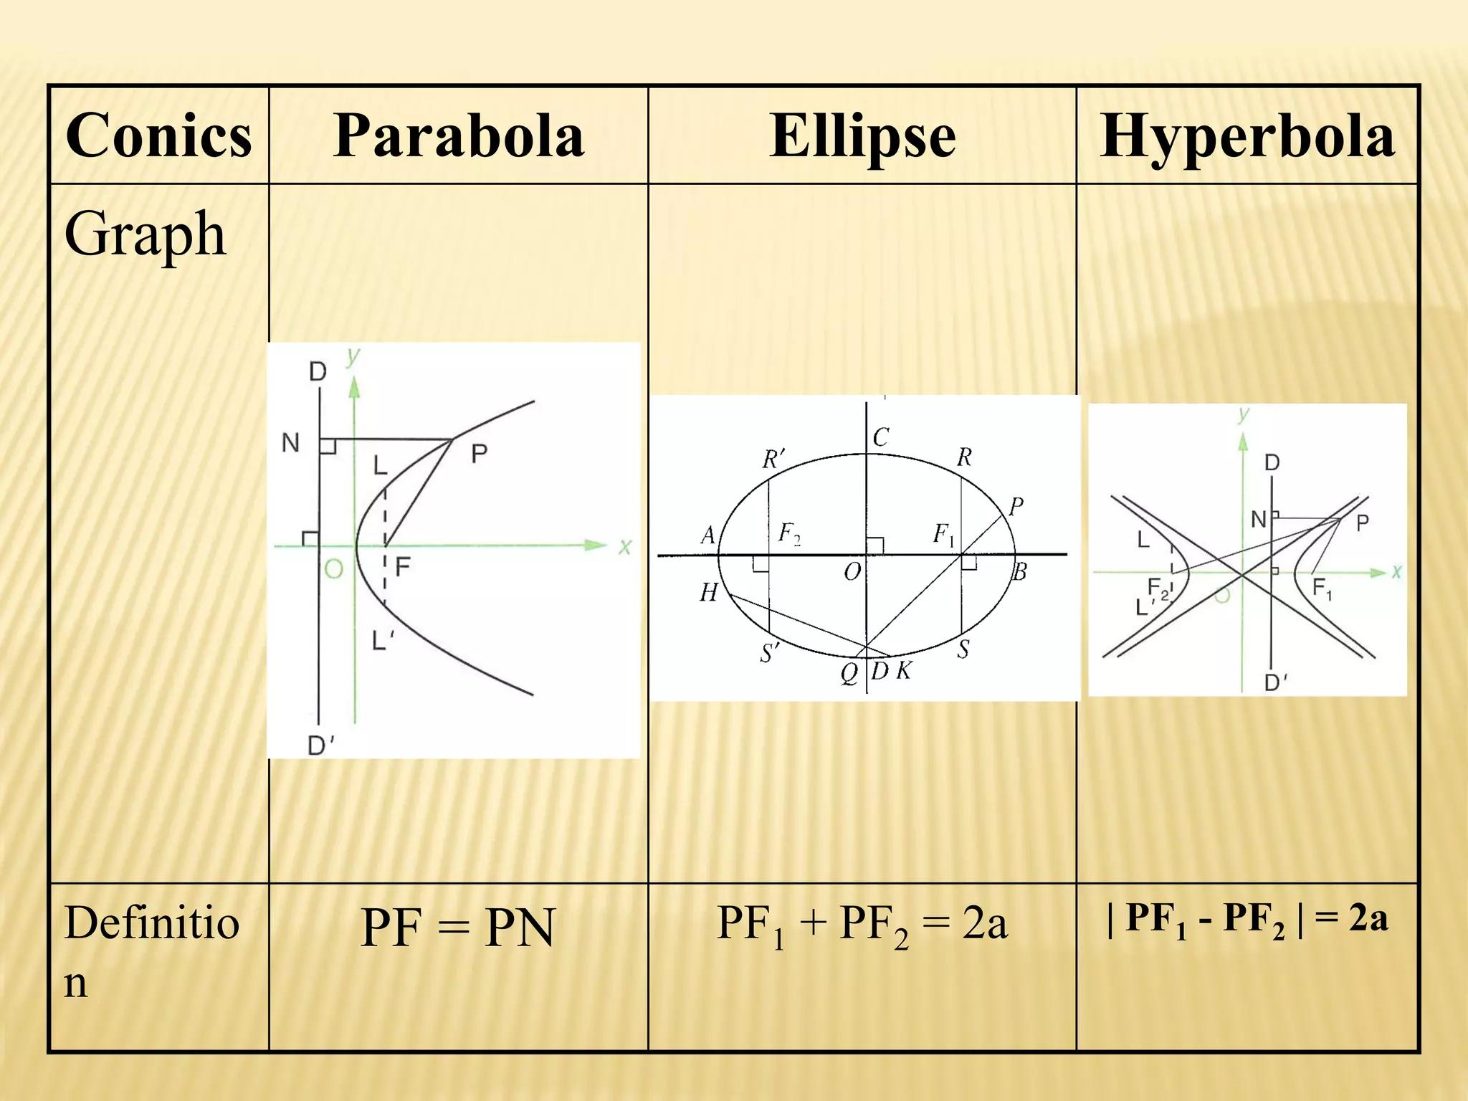
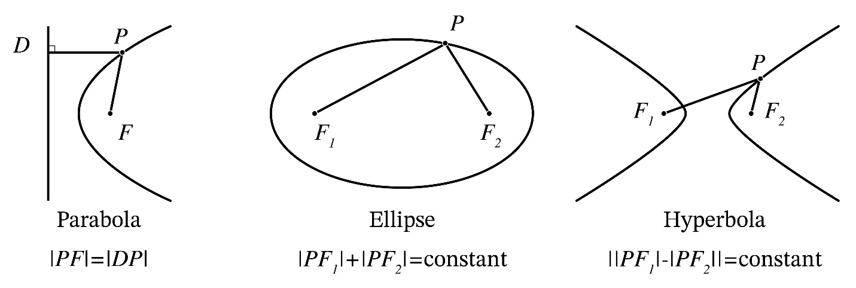

Relationship with Conic Sections
# Source: AI Source: Provided by: [Data Path: Persons Table -> ID Column: 1, Name_En Column: Motasem Essam] -> From: [ChatGPT] on [7/25/2026]
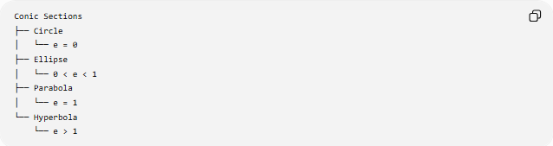
Conic Sections
├── Circle
│ └── e = 0
├── Ellipse
│ └── 0 < e < 1
├── Parabola
│ └── e = 1
└── Hyperbola
└── e > 1
The hyperbola is therefore the conic section characterized by:
$$\boxed{e>1}$$

Real-World Applications
# Source: AI Source: Provided by: [Data Path: Persons Table -> ID Column: 1, Name_En Column: Motasem Essam] -> From: [ChatGPT] on [7/25/2026]
Hyperbolas appear in:
- Astronomy
- Orbital mechanics
- Navigation
- Radio positioning
- Physics
- Optics
- Engineering
- Architecture
- Structural design
- Signal localization
- Computer graphics
A particularly important application is hyperbolic positioning, where the difference in arrival times of signals can determine a location.
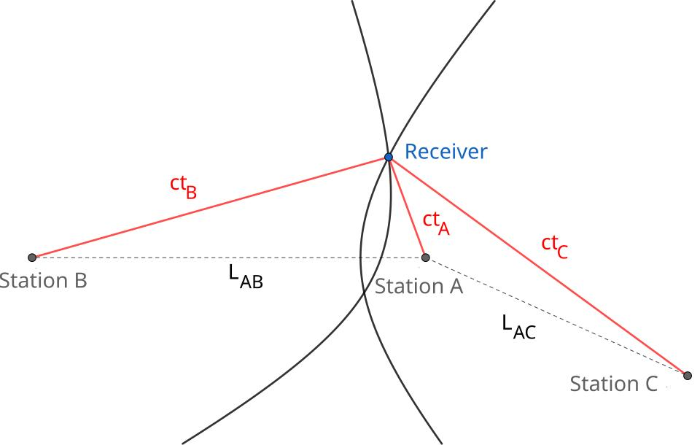

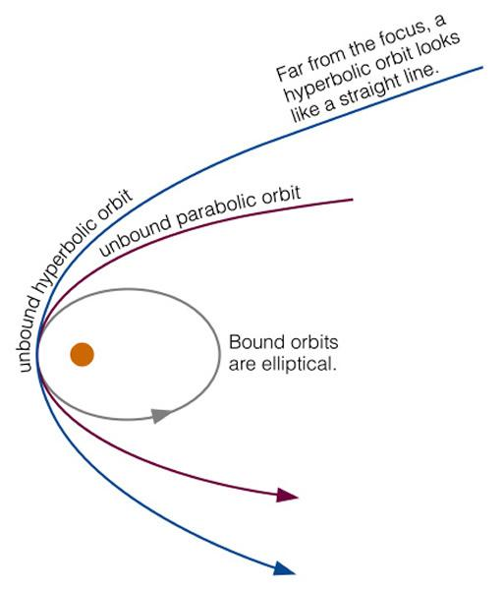
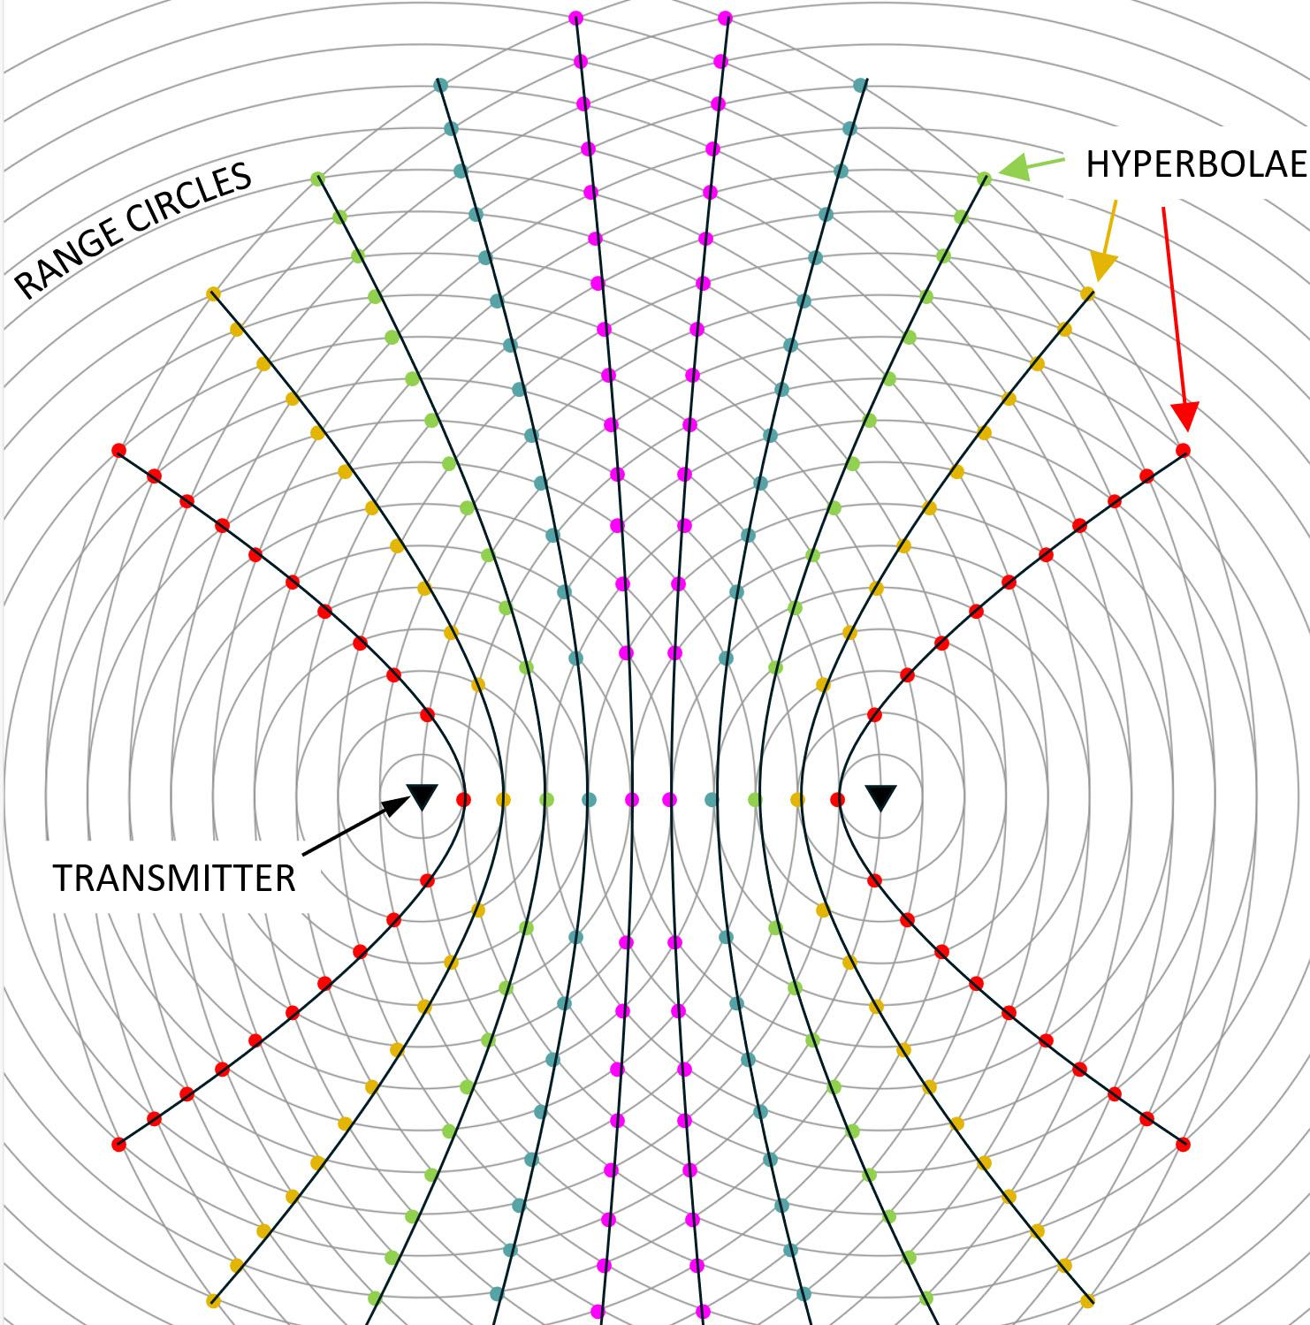
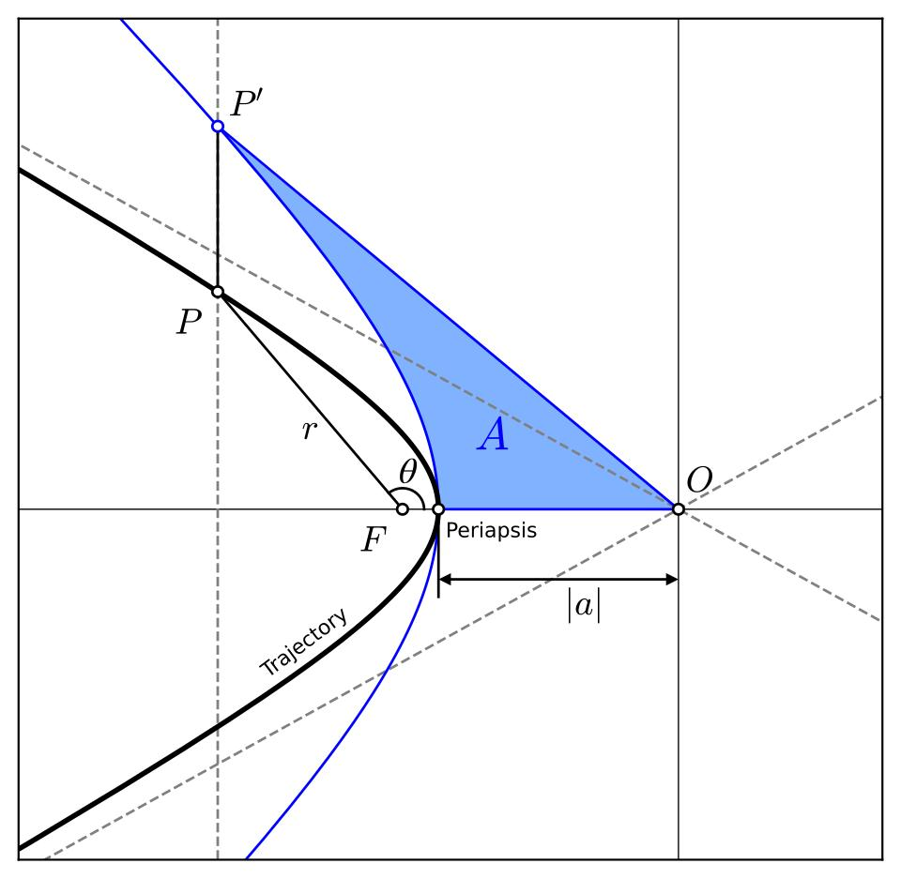

Key Formulas
# Source: AI Source: Provided by: [Data Path: Persons Table -> ID Column: 1, Name_En Column: Motasem Essam] -> From: [ChatGPT] on [7/25/2026]
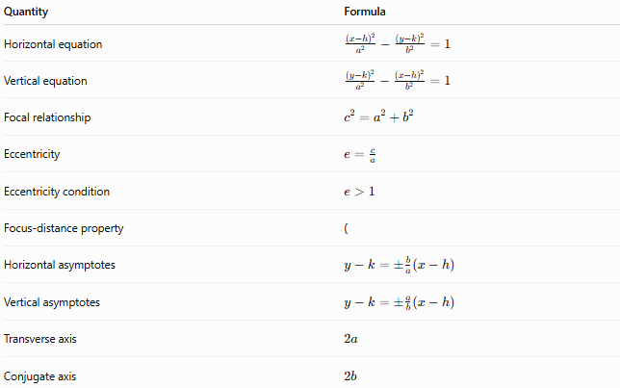
Quantity | Formula
Horizontal equation | $$\frac{{\left(x-h\right)}^{2}}{a^{2}}-\frac{{\left(y-k\right)}^{2}}{b^{2}}=1$$
Vertical equation | $$\frac{{\left(y-k\right)}^{2}}{a^{2}}-\frac{{\left(x-h\right)}^{2}}{b^{2}}=1$$
Focal relationship | $$c^{2}=a^{2}+b^{2}$$
Eccentricity | $$e=\frac{c}{a}$$
Eccentricity condition | $$e>1$$
Focus-distance property | (
Horizontal asymptotes | $$y-k=±\frac{b}{a}\left(x-h\right)$$
Vertical asymptotes | $$y-k=±\frac{a}{b}\left(x-h\right)$$
Transverse axis | $$2a$$
Conjugate axis | $$2b$$

Key Points
# Source: AI Source: Provided by: [Data Path: Persons Table -> ID Column: 1, Name_En Column: Motasem Essam] -> From: [ChatGPT] on [7/25/2026]
- A hyperbola has two branches.
- It has two foci.
- The absolute difference of the distances to the foci is constant.
- That constant is $2a$.
- $a$is the semi-transverse axis.
- $b$is the semi-conjugate axis.
- $c$is the center-to-focus distance.
- The fundamental relationship is:
$$\boxed{c^{2}=a^{2}+b^{2}}$$
- Its eccentricity is:
$$\boxed{e=\frac{c}{a}>1}$$
- Every standard hyperbola has two asymptotes.

Conclusion
# Source: AI Source: Provided by: [Data Path: Persons Table -> ID Column: 1, Name_En Column: Motasem Essam] -> From: [ChatGPT] on [7/25/2026]
A hyperbola is an open conic section consisting of two branches. It is defined geometrically by a constant difference between the distances from any point on the curve to two fixed foci.
Its most important relationships are:
$$\boxed{∣PF_{1}-PF_{2}∣=2a} \\ \boxed{c^{2}=a^{2}+b^{2}} \\ \boxed{e=\frac{c}{a}>1}$$
Thus, among the principal conic sections, the hyperbola is uniquely characterized by an eccentricity greater than 1.

